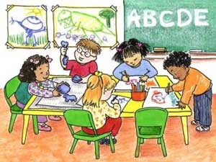
What will your child learn in preschool?

Photo by University of Michigan

Arts and Crafts
Language Development
Large and Fine Motor Skills
Math Readiness
(i.e. counting, number recognition)

Music
Reading Readiness
(i.e. alphabet recognition, letter sounds)

Science
Social Skills
Spiritual Development
(i.e. prayers, bible stories, and songs)
We Can Use
Your Help!
We are in need of the following items:
- large plastic containers with lids & handles
- outgrown toys, books, games
- paper
- craft supplies
- collage materials
- small plastic cups with lids
- large brown grocery bags

Please share ideas for field trips or special visitors
with us!

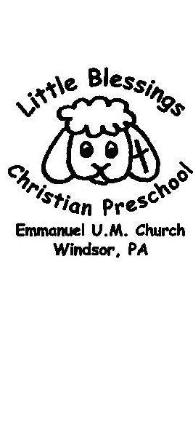
A weekday program of
Emmanuel United Methodist Church
2185 Windsor Road, P.O. 341
Windsor PA 17366

www.emmanuelumcwindsorpa.com
Facebook: @emmanuelumcwindsor

For more information contact:
Director – Jodi Hinton, (717)968-1898
littleblessingspreschoolwindsor@yahoo.com

