Mission Statement
Little Blessings Christian Preschool will provide a safe, loving Christian atmosphere where young children can grow
intellectually, socially, emotionally, physically, & spiritually.

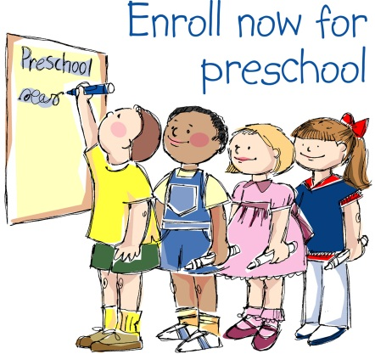

Photo by ChildLifePreschool

Open House Dates:
Sat., April 6th 11 AM
Sat., April 13th 11AM
(Both ending at noon)
Preschool Programs

2 DAY
THREE YEAR OLDS

September thru May
Tuesday and Thursday
9:15 – 11:30 AM

$85 per month

3 DAY
FOUR YEAR OLDS

September thru May
Monday, Wednesday, and Friday
9:15 – 11:30 AM

$105 per month
**Non-refundable Annual Registration $30

Little Blessings Preschool’s Home

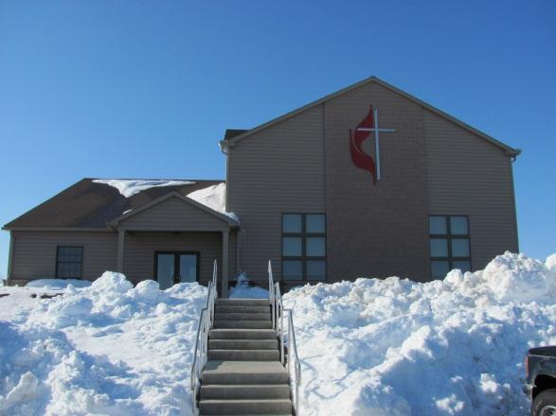

Emmanuel United Methodist
Church
2185 Windsor Road
Windsor, PA 17366
Pastor Harold (Butch) Snyder
Sunday School 9AM
Sunday Worship 10:15AM

Children’s Ministries:
*Nursery and Jr. Church
*Children’s Choir
*Youth Fellowship
*Vacation Bible School

