Little Blessings
Christian Preschool
2020-2021 Handbook
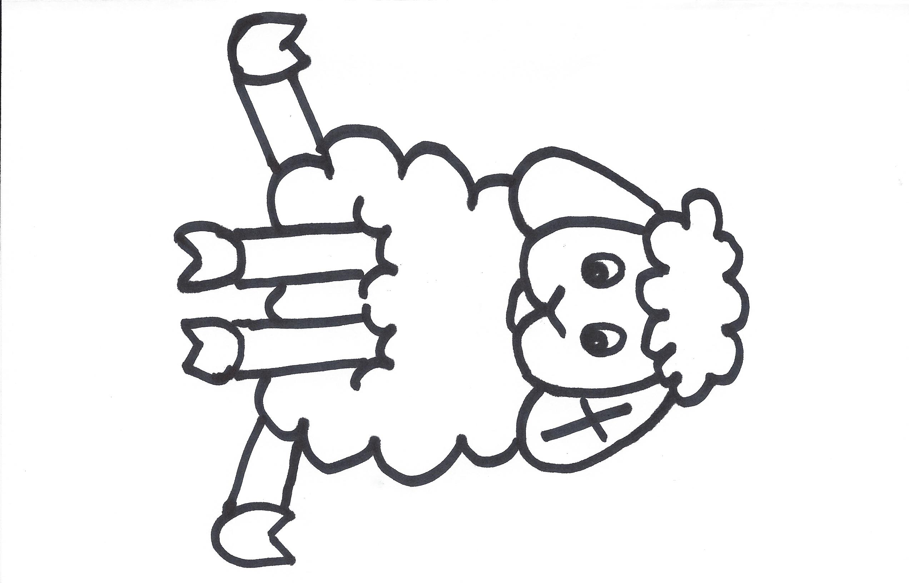

A weekday program of
Emmanuel United Methodist Church
www.emmanuelumcwindsorpa.com
Facebook: @emmanuelumcwindsor
2185 Windsor Rd. P.O.341
Windsor, PA 17366
(717)244-0728

littleblessingspreschoolwindsor@yahoo.com
Jodi Hinton, Director (717)968-1898

Table of Contents
Mission Statement --- 2
Why is Preschool Important --- 2
Our Staff --- 3
Enrollment --- 5
Our Classes --- 6
Calendar --- 7
Tuition --- 7
Arrival/Dismissal Procedures --- 8
Safety Policy ---9
Snow Days/Cancellations --- 9
Dress --- 9
Backpacks --- 10
Paint Shirts --- 10
Show-N-Tell --- 10
Snacks --- 11
Birthdays --- 11
Fieldtrips ---12
Insurance --- 13
Health Information --- 14
Conferences --- 16
Discipline ---16
Substitute Teachers --- 16
Special Visitors --- 17
Donations --- 17

Mission Statement:

“Little Blessings Christian Preschool will provide a safe, loving, Christian atmosphere where young children can grow intellectually, socially, emotionally, physically, and spiritually.”

Why is Preschool important?

- Preschool promotes language development: talking, telling stories, and conversation.
- Preschool offers experiences which help to develop readiness for reading and math.
- Preschool provides experiences with music through songs, dance, and rhythms.
- Preschool develops a child physically through games and activities like skipping, jumping, and marching.
- Preschool develops fine motor skills - tracing, cutting, and painting.
- Preschool provides social experiences: working, playing, and sharing with others his/her own age.
- Christian preschool nurtures the child to grow in God’s love, as well as, learn Christian values and teachings through bible stories, bible songs, and prayer.

2
Our Staff

Jodi Hinton
Director/Teacher
Mrs. Hinton received her degree in elementary education from Lebanon Valley College. She has over 25 years of experience working with children in multiple settings. A member of Emmanuel, Mrs. Hinton has been the director and teacher of Little Blessings for 10 years. She and her husband have three children and enjoy farm life. Mrs. Hinton aspires to provide a strong educational foundation within a loving, nurturing, Christian environment.

Yvonne Dehoff
Teacher Assistant
Mrs. Dehoff lives in Windsor with her husband and two children. She is devoted to caring for her family and strives to meet their needs. She enjoys camping and spending time with her family. She graduated from Conestoga Valley High School and Empire Beauty School and worked for Holiday hair for 13 years. Yvonne feels that preschool is an important element for preparing for school socially and academically.
3

April Fake
Teacher Assistant
Mrs. Fake and her husband are the proud parents of two children. Both her son and daughter attend Eastern York Middle School (Little Blessings Preschool alumni).
She enjoys spending time with her family and friends. She is active in various ministries in her church. She graduated from Red Lion Area High School and Penn State University with a BS in Animal Science. Mrs. Fake feels preschool gives children a jumpstart on their education and gets them excited for kindergarten.

All staff members have met the necessary requirements to provide excellent care for your child. They have passed criminal record clearances and signed a covenant as a part of Emmanuel’s Safe Sanctuary regulations for the protection against child abuse.

4
Enrollment

- Children who are 3 years old up to kindergarten age are eligible to enroll in the preschool. Admission requirements and enrollment procedures are listed below.
- A child must be 3 years old by August 31 to be admitted into the three-year-old class.
- A child must be 4 years old by August 31 to be admitted into the 4-year-old class.
- All children must be toilet trained.
- If classes are filled when a parent calls, the child’s name will be placed on a waiting list to fill vacancies as they occur.
- Parents/guardians of enrolled children will be given priority registration for the following school year. Siblings will also be given the opportunity for early registration.
- Completion of the enrollment application and payment of a non-refundable registration fee will secure a child’s place in the program.
- Children are admitted to school regardless of race, religion, sex, or ethnicity.
- A child with a physical, mental, or emotional special need that requires special care will be accepted on an individual basis.
- If an opening is available, enrollment may take place anytime during the year.
- When enrolling your child, there are several papers that need completed for our files.

5
Our Classes
6

3-year-old class:
Tuesdays and Thursdays
9:15 a.m. - 11:30 a.m.
Mid. September - Mid. May

Cost: $30 Registration (non-refundable)

Tuition: $85 per month

4-year-old class:
Monday, Wednesday, Friday
9:15 a.m. - 11:30 a.m.
Mid. September - Mid. May

Cost: $30 Registration (non-refundable)

Tuition: $105 per month

Calendar
7

A schedule of class days and holiday closings is distributed at the beginning of school. A monthly calendar will be sent home listing areas of study and special events.

Tuition
Tuition is due the first of each month. Payments should be given to the teacher. Checks should be payable to Little Blessings Christian Preschool. Refunds are not given for missed days during the month. Please keep your account current. It is necessary that tuition be paid on time in order to maintain a quality program. The treasurer will send a letter to a parent/guardian failing to pay tuition by the 10th of the month that it is due and a $10.00 late fee will be charged. If a financial problem arises, inform us immediately so we can work out a payment plan. In addition, returned checks will be assessed a $35.00 charge per return. After two returned checks, you will be required to pay in cash. If you are going to withdraw your child from the school, two weeks’ notice must be given, in writing, to the director. We can then allow a child from our waiting list to enter in his/her place. There will be no refunds of any fees paid to the program
7

Arrival/Dismissal Procedures

Our day begins at 9:15 a.m. and ends at 11:30 a.m. Please do not bring your child earlier than 5 minutes before class begins and pick them up no later than 5 minutes after class has ended. The fee is $5.00 for every 10 minutes beyond the pick-up time.

For safety reasons children must always be left in the care of an adult. Do not allow your child to enter the building alone. Children must never be left at preschool without a teacher or assistant present. Please park in the lower lot and use the steps. Remember to turn off your car engine.

At dismissal time, the children will be dismissed at the church door. A teacher will walk the child out to the car and assist you in buckling your preschooler. Enter the lower lot and circle counter clockwise to the entrance. You will be given a name tag to hang in your car for easier dismissal.

If someone, other than the usual person, is picking up your child, please send a note and identify the person with whom he/she is traveling. If it becomes necessary to change plans during school, please call us at (717)244-0728 or (717)968-1898. We will need to see a photo I.D. of the person picking up the child.
Kindly advise us of any carpool schedules.
8

Safety Policy

Our school doors are locked by 9:30 a.m. and reopened at 11:30 a.m.

Snow Days and Cancellations

We will follow Red Lion Area School District’s announcements for weather closings. If the district is closed, we will be closed. If the district is operating on a delay, we will begin at 11:15 and have class until 1:30 PM. Please pack a lunch to eat at school. If driving conditions worsen during school hours, please pick up your child early. You will be notified by email or phone message regarding any changes in schedule.

Dress

Children are encouraged to wear play clothes and safe shoes, preferably sneakers. Do not send your child to school in sandals, clogs, crocs, or flip flops. Your child’s name should be on all clothing and personal belongings.

A change of clothes may be placed in a Ziploc bag to be stored at school if needed. Please label bag with name.
9

Backpacks

Please provide a backpack for your child to transport his/her papers and show and tell items. Please label the outside of the backpack with your child’s name. Please send the backpack each day. The backpack should easily hold an unfolded 8.5 x 11 inch paper.

Paint Shirts

Children may bring in an adult size T-shirt which has his/her name printed on the front.

Show -N- Tell

A schedule will be sent home regarding an assigned day for sharing a toy or game from home. Please label with a piece of masking tape and his/her name. Please remember NOT to bring toy weapons or any item of great value because it could possibly get broken.

10

Snacks

The children are served snacks each day. Donations of healthy snacks, juice or milk are appreciated. A snack schedule will be sent home. If you are unable to donate or forget to send in a snack, we always have extra snacks on hand. Due to the number of children with food allergies, a list of snacks that are safe for all children will be provided.

Birthdays

Children enjoy celebrating their birthday at school. You may provide special treats and send in napkins and cups for everyone. Small, individual portions, like mini cupcakes, brownies, cookies, finger Jell-O, and popsicles are easily managed. Children with birthdays in the summer can celebrate their birthdays in April and May.

11
Field Trips

Each class will take a number of field trips this year. Fees for the students are covered by the school. Learning about the world outside the classroom is great fun! What an opportunity to spend some one-on-one time with your child. Plus, you also get to know other families and make lasting friendships.

Your teacher will send home the details of the trip in advance. A permission form will be sent home for each trip. Parents are asked to drive for field trips. We carpool whenever possible. On the permission slip, you must list the number of seat belts and car seats in your vehicle. Children are not permitted to sit in the front seat. Drivers’ insurance coverage must be current. Parents who are not able to attend are asked to leave their labeled seats in the hallway.

A separate field trip form must be completed and returned to your child’s teacher. These forms will be taken on each field trip for easier access of important information if needed. Thank you.

12
Insurance

Liability insurance is carried on all children for injuries that may occur while in attendance at Emmanuel United Methodist Church. If your child is injured seriously, the staff will administer first-aid and contact the parent or authorized adult, as well as, the child’s physician.

13
Health Information

For our records, the preschool must have (on file for each child) a signed Emergency Form. Emergency numbers for reaching the parent/guardian or designated contact person must be on file. Please fill out and return to your child’s teacher. Please notify us immediately if your telephone or address changes.

Keeping your child at home when any of the following symptoms occur can control communicable diseases:
- Excessive nasal discharge and sneezing
- Fever, or has had one during the previous 24-hour period
- Excessive coughing
- Undiagnosed rash
- Itching, red or infected eyes
- Earache
- Vomiting and diarrhea
- Excessive scratching of the scalp
- Infected skin patches

14
If your child has a communicable disease, please notify the school so that other parents can be informed and may monitor their child for symptoms.

Also, please keep your child out of school until your physician decides the child can return without danger to himself or other children and staff.

If your child is fussy, tired and generally not himself/herself, please keep them at home to rest.

15
Conferences

Conferences will be scheduled with the teacher in the spring. Parents may request a conference at any time.

Discipline

Children will be given positive reinforcement for appropriate behavior. If a child repeatedly chooses an inappropriate behavior, he/she will be removed from the group for a time-out. If behavior problems persist, a parent/teacher conference will be scheduled and a behavior modification plan will be implemented. If you have any questions about a situation or a correction, please call the teacher.

Substitute Teachers

We are always looking for substitutes. If you are interested, please inform us. We will see that you receive the necessary paper work. Clearances will be required.

16
Special Visitors

If you or someone you know has a special talent or interest and would like to share with the children, please let us know. Also, if you would like to be a guest reader/story teller please inform us.

Donations Needed

- Coffee cans and oatmeal containers
- Large plastic containers with lids
- Outgrown toys, books, and games
- Paper-all sizes and colors
- Collage materials, pom-poms, foam crafts
- Large brown grocery bags
- Fast food toys
- Plus, anything else you think we might be able to use, just ask!

17

